European Union
European Fund for Regional Development




„По- близо, по- близки..."

MINISTRY OF TRANSPORT, INFORMATION TECHNOLOGIES

AND COMMUNICATIONS
OF THE REPUBLIC OF BULGARIA

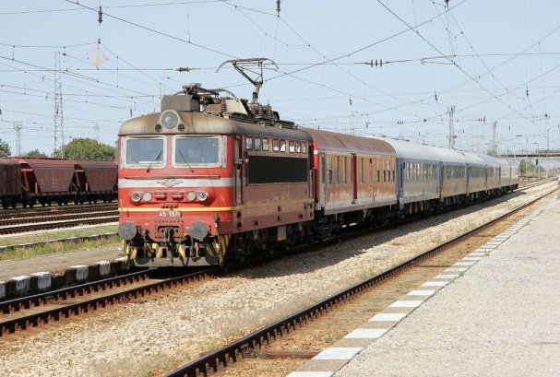
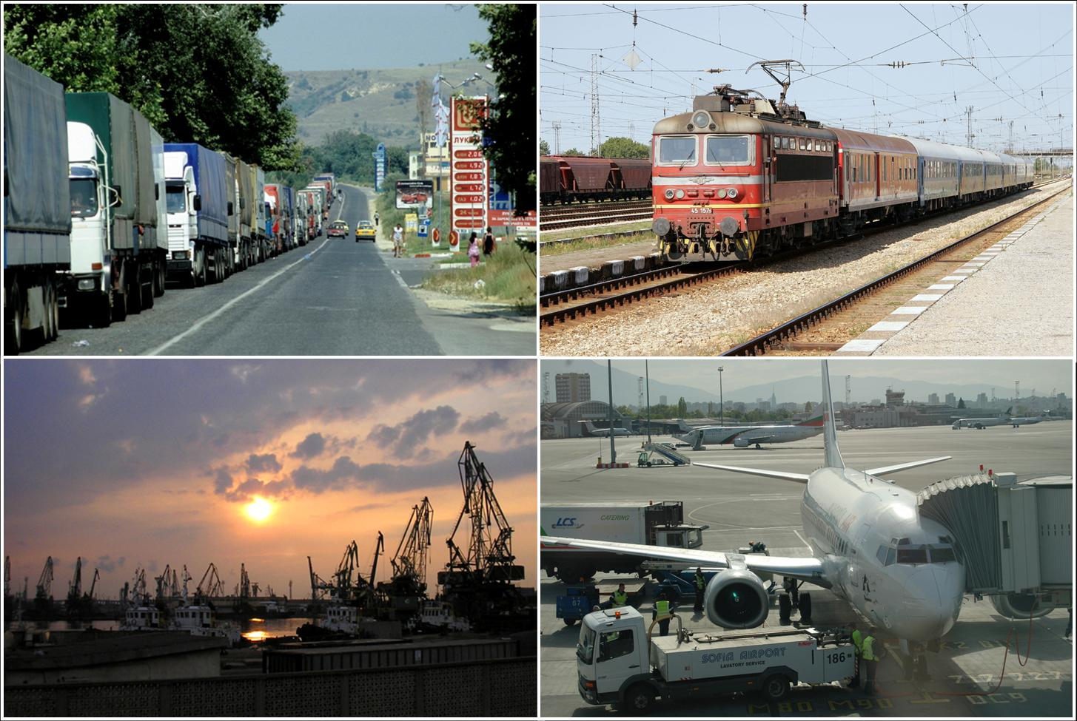
PREPARATION OF GENERAL TRANSPORT MASTER PLAN OF BULGARIA

Environmental Assessment of General Transport Master Plan

(FINAL REPORT)—NON - TECHNICAL SUMMARY
January 2010

Prepared by: Checked by:
Diana Straka David Pontefract
Experts team manager Team Leader
EIA and EA

Rev No | Comments | Date
1 | Environmental Assessment Report | 14/01/2010

Landmark Centre, 14 Tzar Osvoboditel Blvd.Sofia 1000, Bulgaria
Job No No 60044791 Reference KR9 Date Created: January 2010

This document has been prepared by AECOM Limited (AECOM) for the use of The Bulgarian Ministry of Transport, Information Technology and Communications (the “Client”). Any information provided by third parties and referred to herein has not been checked or verified by AECOM, unless otherwise expressly stated in the document.

No third party may rely upon this document without the prior and express written agreement of AECOM.

Introduction
TABLE OF CONTENTS
1
1 Description of primary plan objectives and relationship with other relevant plans and programs 4
1.1 Status of the transport sector in the Republic of Bulgaria 4
Highway transport 4
Rail transport 5
Water transport 6
Air transport 6
1.2 “Transport” sector weaknesses 7
1.3 Plan characteristics 7
1.4 Primary plan objectives and identified priority projects 8
R21 13
A01 16
1.5 Plan relationsip with other relevant plans and programs 20
2 Current environmental status and possible development without the Plan implementation 22
3 Characteristic of the environmental areas that are likely to be significantly affected 26
G. Problematic areas for wildlife in the road network and priorities for planning of long-term defragmentation measures 30
4 Existing environmental problems, identified at different levels, relevant to the plan, including these related to areas of particular ecological importance, as the protected areas under Biological Diversity Act 33
5 GTMP objectives for environmental protection at national and international level 37
6 Possible significant environmental impacts 39
7 Measures, envisaged to prevent, reduce and most efficiently compensate the adverse impacts on environment, resulting from the Plan implementation 43
А. Measures to be included in the Final GTMP version 43
8 Description of reasons for selection of alternatives and methods to perform the environmental assessment, including the difficulties in collection of the required information, regarding technical imperfections and lack of know-how. 50
9 Description of the necessary monitoring related measures during the Plan implementation 53
10 Resuls of consultations on the Environmental Assessment 57
11 Summary of results and conclusion 59

The General Transport Master Plan (GTMP) of the Republic of Bulgaria is prepared in comliance with the set out corrective actions of Priority Axis 5 „ Technical Assistance” of the Sectoral Operational Program Transport (SOPT) for 2007-2013. After the preparation, approval and adoption of the plan, it will become an integral part of SOPT.
Introduction
The proposer of GTMP is Ministry of Transport, Information Technologies and communications (MTIC). The beneficiary of the projec is “Coordination of Programs and Projects” Directorate in MTIC, which is the Managing Authority of SOPT.
The main objective of the General Transport Master Plan is the establishment of a strategic and coherent base of technical data, transport models, multimodal technical studies for project identification for long and medium term investment programming in the transport sector in Bulgaria. These technical studies should possess a high degree of consistency, through the appropriate elaboration of a transport master plan. The plan refers to the period of SOPT, but will serve as the basis for planning for the next programming period 2014-2020.
The GTMP preparation is assigned to an open procurement procedure by Faber Maunsell Aecom. Presentation of the results is carried out in 13 consistently developed Key Reports 1-13 and a Final Report.
Pursuant to the key actions under 5 and 6 of the Technical Specification (Technical Terms of Reference) for the project “Preparation of General Transport Master Plan”, the development of GTMP includes Parallel development of environmental assessment as part of the plan, presentedin Key Report 9.
The EA of GTMP purpose is to analyse and assess the potential impacts on the components and environmental factors, resulting from the implementation of GTMP at the earliest possible stage of planning, before adoption of the plan.
Although the environmental assessment is presented as Key Report 9, its preparation commenced with the preparation of the Key Report 4 “Option Identification Report”, through which the development of EA is integrated in the process and stages of planning at its ealiest stage, and that will allow at the maximum possible extent to identify the potential impacts on the environment, to compare the alternatives of the plan implementation and make recommendations for a reasoned choice of environmental alternatives.
The content and detail level of the plan appraisal does not allow to forecast the exact location, nature and amount of the predicted impacts, therefore, the assessment aims at the earliest possible indication of the potential impacts.
Based on the analysis results on the potential negative/adverse impact, the team of registered experts, preparing EA, will undertake the task to propose adequate measures, minimizing the adverse effects on the environment. The measures will form the next stages of detailed design and implementation of specific investment projects, as this plan will provide the guidelines for their development.
Since GTMP has a national scope, its predictions are likely to affect both protected areas under the Protected Areas Act, and protected areas of ecological network Natura 2000. In this regard, during the consultations on the scope and schedule for consultation on EA ( letter No 04-00-2320/07.10.2009) MEW has performed a verification of eligibility under Article 36, Paragraph 2 of the Regulation on procedures, in order to assess the compatibility of plans, programs, projects and investment proposals with the object and purpose of preservation of protected areas, that found GTMP to be eligible, if considered the attendant programs, projects and investment proposals relating to:
- Regimes for the protected areas, set out in the Protected Areas Act, the orders for their designation and the approved management plans;
- Regimes for the protected territories, set out in the orders under Art. 12, Para 6 of the Biological Diversity Act.
Under Article 36, Para 3 in the Regulation on procedures to assess the compatibility of the plans, programs, projects and investment proposals with the object and purpose of preservation of protected areas, an appraisal on the probable degree of negative impact was made, according to which GTMP is unlikely to have significant negative impacts on natural habitats, populations and habitats of species, subject to preservation in protected areas of the Natura 2000 network.
Under the consultation scheme, until now, consultations have been conducted with Ministry of Environment and Water, Ministry of Health, State Forestry Agency, all Regional Inspectorates for Environment and Water and Basin Water Management Directorates, on the report prepared, related to the scope and scheme for consultation on GTMP, EA. The received opinions are provided in it.10.1. On the developed Preliminary EA have been conducted consultations with the above competent authorities. The results are presented in it.10.2. of the EA report.

The numbers of tables and figures in NTS correspond to these in EA.

- Description of primary plan objectives and relationship with other relevant plans and programs
- Description of primary plan objectives and relationship with other relevant plans and programs
  - Status of the transport sector in the Republic of Bulgaria
Bulgaria has a strategic geographic position in Europe. The favorable geographical location of the country can be seen clearly by the passage, through the country, of five Trans-European corridors: 4, 7, 8, 9 and 10, which are discussed in detail below:
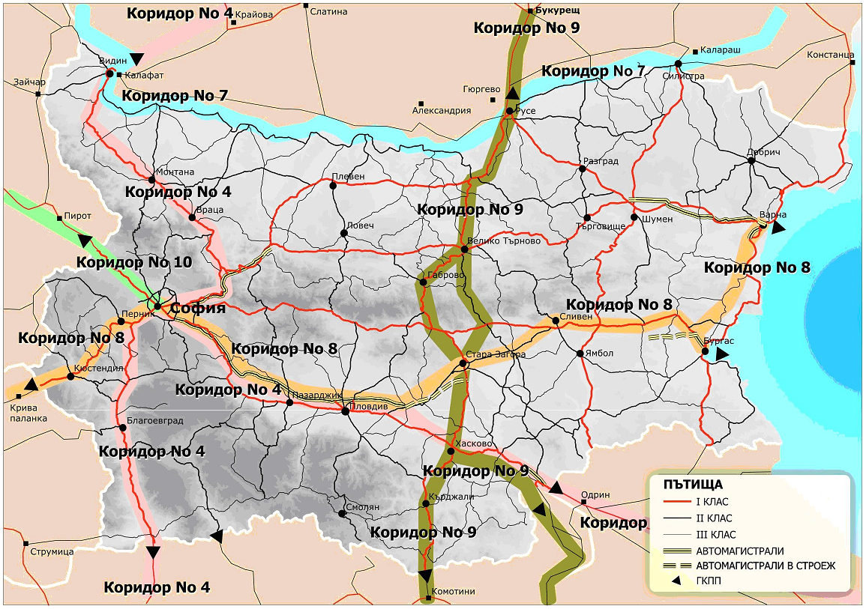
Figure 1. European Transport Corridors (TEN-T)

Highway transport

The National highway network includes motorways and highways Class I, II and III, part of which are involved in the Trans-European highway network.
The local highways are municipal and private, open to use by public, providing transport links of local significance and are related to the Republican highways or streets.
The Strategic highway network in Bulgaria is planned to cover six major routes: A1 “Trakia” Motorway, A2 “Hemus” Motorway, A3 “Maritsa” Motorway, A4 “Black sea” Motorway, A5 “Lyulin” Motorway, A6 “Struma” Motorway.
Bulgaria borders with Serbia and Macedonia to the west, with Greece and Turkey to the south, with the Black Sea to the east and with Romania to the north. Therefore, Bulgaria is a transit country for many Trans-European links. Five of the ten European Corridors (E-highways) are crossing the territory of Bulgaria. The overall their length is approximately 1900 km.
The available and the planned motorway sections in Bulgaria are now or will become some elements of the TEN-T infrastructure
A significant part of the Republican highway network has not been repaired for more than 15 to 20 years, despite the fact, that the statutory standard for regular repairs is 5 to 7 years, and 12 years for renewal works.

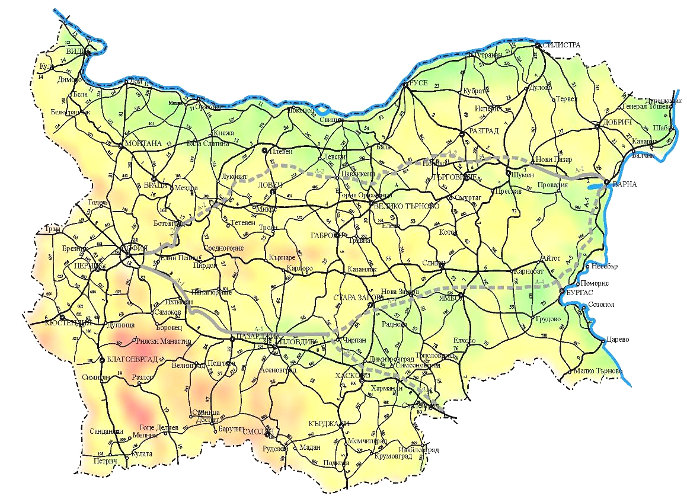
Figure 2. National Highway network in Bulgaria

Rail transport
The Bulgarian railway network consists of 4,316 km railways, 94.3% of which are standard gauge, and the remaining 5.6% are close gauge (760 mm). Only 22% of the whole system is with double rails, and 70% is electrified, representing a higher than the average European level. There exist 400 railway stations and 300 railway station stops.

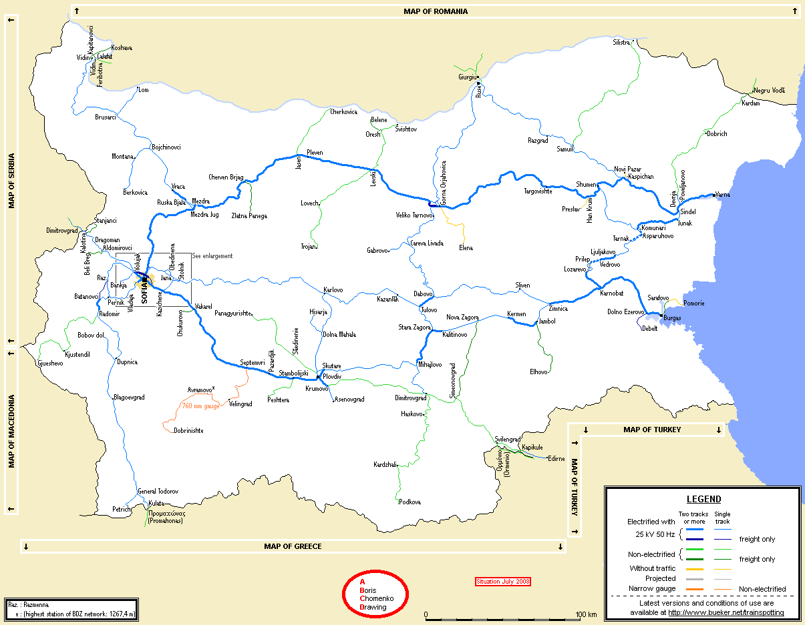
Figure 4. Bulgarian Rail Network 2008

Bulgaria has a densely distributed railway networkof 0.036 km/km², placing it only after the Czech Republic, compared to smaller European countries (France is included, in the comparison, as a big country). This is a value, which if attributed to the population density, can illustrate the good accessibility of the railway network.
At present 42% the Bulgarian railway network is a part of the above stated Trans-European Corridors.
The maintenance of the railway infrastructure is the basis for the capabilities of the Bulgarian railway system. The ability to manage the train safety and the required frequency and speed, depend on the rail, structural, electrical and signaling systems conditions.
All the sectors in the Bulgarian railway industry recognize, that since 1989 the railway infrastructure has been seriously suffering a deficiency in the maintenance and replacement of equipment.

Water transport

А. Sea ports
The current sea port capacity is calculated by the Ministry of Transport to amount 30-35 million tonnes/year. The total output of the Black Sea ports for 2006 was 27.5 million tonnes, including 17.6 million tonnes through Burgas port and 9.9 million tonnes through Varna port. The total output for 2007 was lower - around 26 million tonnes.
B. River ports – the Danube River
After the completon of the Primary Rhine-Main-Danube Channel in 1992, the Danube River became part of the Trans-European waterway from Rotterdam in the North Sea to Sulina on the Black Sea (3500 km). In 1994 the Danube was declared one of the Trans-European waterways. The current river port capacity is calculated by the Ministry of Transport to amount 10mtpa. The main ports on the Danube are Ruse and Lom.
Air transport

There are five international civilian airports in Bulgaria: Sofia, Varna, Burgas, Plovdiv and Gorna Oryahovitsa.
In addition, there are three in-operative airports in Ruse, Targovishte, Stara Zagora, and several certified aircraft sites. Their locations are shown in the Figure below.

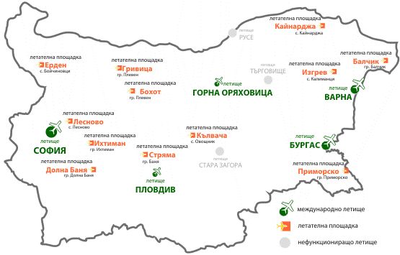
Figure 11. Map of airports and certified airport sites

GTMP focuses on the characteristics of the five international airports and three civilian in-operative airports. These are the airports listed in the “Strategy for transport infrastructure development in the Republic of Bulgaria until 2015”, June 2006.

  - “Transport” sector weaknesses

In GTMP developing have been identified the gaps in transport networks, systems and management, that require attention to be given, in order to overcome the weaknesses in the sector, in the context of the available and predicted future demand for transport services. They are listed in it.1.2. of Ea and Key Report 4.

  - Plan characteristics

The requirement for such a Master plan arises from the need of the Republic of Bulgaria to achieve a clear and coherent planning framework for the development of the transport sector, as well as for short/medium term investment programs and guidelines for identification of long term projects.
Based on a detailed analysis on the current status of the transport system and, in accordance with the national and European priorities for the Transport sector, GTMP is the basis for all the further planning activities in the field of transport: a system of projects to be funded by the Cohesion Fund and European Regional Development Fund, planning of transport infrastructure projects for funding from the state budget; projects for funding from other international financial institutions, public-private partnerships, privately-funded initiatives, etc. This plan will form the basis for future funding requests, therefore it must be sufficiently detailed and reliable. GTMP covers the overall conditions and needs of transport in Bulgaria concerning its oveall territory, including rural regions. The scope includes all modes of transport and travels to, from and within Bulgaria.
The internal public transport is not included in the planning/plan.
The contents and level of detail of the plan forecasts are general- they provide an outline of possible investment projects for funding in the transport sector, but at this stage, the preferred transport schemes could not be designated.
The Plan is developed in 13 Key Reports and 1 Final Report:
Table 8. List of GTMP Key Reports
No | Report Title | Report Summary
KR1 | Transport Model Development Report | This report presents an analysis of the confirmed mathematical transport models, representing the principal movements of people and goods within, to, from and through Bulgaria.  It is based on surveys of actual travel and movement, obtained by direct surveys.  The model will inform about the planning of transport schemes, providing a clear picture of the state of transport demand and supply services in Bulgaria.
KR2 | Analysis of Existing Transport System and Weaknesses to be Overcome | Based on the transport model for a "base year", it analyses the current supply and demand, travel conditions, and deficiencies and weaknesses in the infrastructure, services and systems.
KR3 | Analysis of Future Transport Demand and Future Weaknesses to be Overcome | In this report, the initial prognoses for the transport sector demand in 2015 and 2030 are used to confirm the gaps that would exist in the future, in realization of the forecast transport traffic scenario.
KR4 | Option Identification Report | This report identifies the possible options to overcome the existing and future gaps in the provision of transport services.  The starting point are the projects listed in OTPS.  Some additional projects have been considered, proposed by stakeholders, to reflect the all proposals.
KR5 | Appraisal Framework Report | This report presents the methodology for project appraisal.
KR6 | Initial Appraisal of Options | Key Report 6 presents the results of the initial appraisal of the long list of transport options, identified in Key Report 4, using the appraisal methodology set out in Key Report 5.
KR7 | Detailed Appraisal of Options Report | Key Report 7 presents the results of the detailed appraisal of the short list of transport options, listed in Key Report 6, using the appraisal methodology set out in Key Report 5.
KR8 | Transport Master Plan Report | This report presents the overall strategy for transport development and identifies the final priority options for OTP funding.
KR9 | SEA Environmental Report | The report has been prepared since the outset of the planning process and is now at : Preliminary EA (current document).
KR10 | Asset Maintenance Strategy Report | Forthcoming
KR11 | Implementation and Funding Strategy | Forthcoming
KR12 | Monitoring and Evaluation Strategy | Forthcoming
KR13 | Human Resource Development Strategy | Forthcoming
FR | Final Master Plan Study Report | Forthcoming

  - Primary plan objectives and identified priority projects

The main objective of the General Transport Master Plan is clearly set out out in the Technical Specification, prepared by the Bulgarian Ministry of Transport, as being: “the establishment of a strategic and coherent base of technical data, transport models, multimodal technical studies for project identification for long and medium term investment programming in the transport sector in Bulgaria. These technical studies should possess a high degree of consistency, through the appropriate elaboration of a transport Master plan”.
The result of GTMP study is also the progressive choice and prioritization of an indicative list of infrastructure projects to be funded through OTP.
In the context of GTMP priority projects and options are considered to be the plan indicated opportunities and directions for the transport development, transport modes, new construction or modernization of transport infrastructure.
Any specific investment proposals have not been detailed, as this requires much more detailed study and analysis, which is not a subject of this plan.
The options for transport development are selected and prioritized in 4 stages, detailed in it.8.2.of EA.
STAGE ІV Key Report 8 presents the proposal for a comprehensive GTMP strategy and identifies the priority projects that should be considered as an onset of its implementation.
As a result, the final list in KR 8 identifies the following priority projects:
  - Highway transport – (H) – 17 projects;
  - Rail transport – (R) – 14 projects;
  - Water transport (W) – 15 projects;
  - Air transport (A) – 5 projects;
  - Inter Modal transport (IM) – 5 projects;

The priority projects are presented in the following table, and each project is supported by a brief comment on the presence of EIA procedure held and/or ЕA, pursuant to Chapter Six of the Environmental Protection Act. The projects identified in KR 8 and especially those relating to the corridor and network development, (second and third category) and will be assessed and analysed in the EA, in terms of their impact on the environment and if needed, appropriate measures will be proposed to mitigate the environmental impact as a result of their implementation.
.
Таблица 9. Варианти оценени като приоритетни в Главен доклад 8
Option No | Title |  | Description | Nature of predictions | EIA/EA Procedure stage
H I G H W A Y T R A N S P O R T
H01 | Roads Infrastructure Administration and Network Hierarchy |  | Review of current administrative and organizational structures | More effective actions of the organizational structures | Not subject to the procedure
H02 | Funding and Charging |  | Review of opportunities for infrastructure funding and revenue generation | Provision of funds for urgent and planned construction, reconstruction and highway infrastructure maintenance. | Not subject to procedure
H03 | Network Maintenance Plan and Network Asset Condition Monitoring |  | Development of a maintenance plan with options of funding, priorities and program and establish a system for monitoring on the network assets condition. | General plan for maintenance of overall network and system for all assets condition  monitoring. | Not subject to procedure
H05 | Development of a Road Safety Information and Education Campaign |  | Organizationn of education and information campaign. | Reduced number of accidents | Not subject to procedure
H06 | Driver Information Systems (DIS) |  | Preliminary study on national information system for drivers. | Provision of timely information before or during travel, enabling the drivers to make the best choices for route and time of travel. | Not subject to procedure
H07 | Review of Academic and Professional Training and the role of Research Institutes |  | Review of academic and professional training for transport professionals and engineers, and the role of research institutions. | Increase in the contribution of the research institutes and development and application of new technologies. Motivation of trained and qualified specialists and engineers to work in the sector. | Not subject to procedure
H08 | A1”Trakia” Motorway Stara Zagora to Karnobat |  | Highway А29 – Stara Zagora to Karnobat (115 км) | Provision of continuous motorway route east-west. The detailed projects for investment proposals comply with the environmental legislation and the environmental impacts are minimized through the recommended measures. | LOT 2 St. Zagora - Nova Zagora - EIA and EA not need  LOT3 Nova Zagora - Yambol - EIA and EA;  LOT 4 Yambol – Karnobat EIA and EA;  Stage: Positive appraisal of EIAR quality, public hearings are forthcoming
H10 | A2”Hemus” Motorway Sofia Ring Road to Yana |  | Highway А29 – Sofia Ring highway to Jana (8.5 км) |  | Updated EIA Report.  Forthcoming opinions on EA
H11 | A2 “Hemus “ Motorway Yablanitsa to Shumen |  | Highway А29 – Yablanitsa to Shumen (230 км) | Provision of continuous motorway route east-west in Northern Bulgaria. | The section from Nikyup village to Belopitovo village (km 224+115 to km 341+225 is approved by EIA Decision 6/2008 of MEW. EA is not needed.  For the section from km 90+000 to km 224+115 is forthcoming procedure Under §12б of EPA, related to outdated Decision on EA. Developnment of EA is also forthcoming.
H12 | A3 “Maritsa” Motorway |  | Highway А29 – Chirpan to Harmanli (68 км) | Provision of sufficient capacity to take the large volume of heavy and transit international traffic directed to Turkey. | Updated EIA Report. Presentation is expected.  Opinion submitted on EA 05-EA/2007.
H13 | A4 “Black Sea” Motorway |  | Highway А29 – Burgas to Priseltsi (95 км) | Re-location of transit traffic from the Black Sea towns and villages, being very severe problem in the summer months, in the peak of the tourist season | EIA is prepared. New construction options are proposed. EA is expecting them.
H14 | A6 “Struma” Motorway |  | Highway А29 – Dolna Dikanya to Kulata (138 км) | Motorway route should take the heavy traffic between Bulgaria and Greece. The route follows a river gorge, which at present is difficult to pass at high speed, with many traffic accidents.. | Approved EIA І-1/2008. Positive opinion on EA.
H15 | Sofia Ring Road Northern Arc |  | Highway А35 (minimum) – Renewal of Ring Highway North Arc (22.3 км) | Improved condition, highway properties and maintenance of existing highway, where traffic exceeds the critical limits. | Approved EIA 156-10/1996 г.
H16 | Sofia Ring Road Southern Arc |  | Highway Г20 (minimum) - Renewal of Ring Highway South Arc (28 км) | Improved condition, highway properties and maintenance of existing highway, where traffic exceeds the critical limits. The highway passes through industrial and populated areas and serves the mixed local and transit traffic. | Approved EIA 13-7/2002 г.
H17 | Rila Motorway |  | Highway Г20 – Dupnitsa to Trakia motorway and Hemus motorway (89 км) | Construction of a remote Sofia southern bypass to re-locate the heavy and transit traffic beyond the city borders.  Constuction of connection with Hemus Motorway and Trakia Motorway - no needed to pass through Sofia. | Procedure is not initiated.
H19 | Botevgrad to Mezdra, Vratsa Bypass, Montana Bypass, Ruzhintsi to Dimovo |  | Highway Г20 (new) – Botevgrad to Mezdra  Highway Г20 –Vratsa Bypass  Highway Г20 – Montana Bypass Highway Г10.50 (rehabilitation) – Rujintsi to Dimovo | Construction of first class connection between Vidin and Sofia and no problematic underaking of traffic coming from the Danube bridge II.  Re-location of the heavy and transit traffic beyond the main streets of Vratza and Montana. | Botevgrad-Mezdra - new design. EIAR prepared will be re-prepared before the public hearings.  Vratsa Bypass and Montana Bypass –EIA or EA not required.  Ruzhintsi - Dimovo - forthcoming environmental legislation procedures
H23b | Ruse (Romanian Border) to Makaza (Greek Border) via Veliko Tarnovo, Pass of the Republic, Nova Zagora and Dimitrovgrad |  | Highway Г10.50 (minimum) - Renewal and rehabilitation of Corridor 9 through the Passage of the Republic, including the construction of bypass to Dimitrovgrad | Improved condition and maintenance of the available highway, linking the Bulgarian border with Romania at Ruse and the border with Greece at Makaza passage. Re-location of the heavy and transit traffic beyond the center of Dimitrovgrad. | Procedure for section "Kardzhali - Podkova"exists.  Updated EIA report submitted to the MEW for appraisal.  No need of EIA for the section under rehabilitation. Positive opinion on EA- 05-ОС/2007 г.
R A I L T R A N S P O R Tt
R01 | Railway Administration | Review of the national and regional organization structures |  | Provision of sufficient funds for urgent and planned construction, reconstruction and maintenance of the rail network and associated facilities to provide passenger and freight services. | Not subject to procedure
R02 | Funding and Charging |  | Review of mechanisms for funding and charging | Funding should be not only distributed at annual basis, thus enabling a medium or long term planning of investment in projects for improvement or renewal and maintenance of the available assets. | Not subject to procedure
R03 | Network, Station and Freight Facilities Rationalisation |  | Review of the available assets and rationalization of stations, facilities and rotes | Rationalization of the railway infrastructure, in compliance with the network current needs and avoidance of the problem with maintenance of slightly used infrastructure. | Not subject to procedure
R05 | Asset and Information Management/Network Maintenance Plan |  | Establishment of a complete system for information management and assets register.  Development of a maintenance plan with options for funding, priorities and a program. | Maintenance of the existing assets in the rail network must be efficient and permanent, to ensure the quality, reliability and security of services provided to all passengers, as well as to reduce the operational and maintenance costs. | Not subject to procedure
R07 | Speed enhancements |  | Review of capabilities for high-speed services | Reduced speed limits or other restrictions for proper operation and market requirements for mass transport. | Not subject to procedure
R08 | Passenger Facilities |  | Plan for renewal the facilities at key stations | Improved passenger facilities, which are currently in poor condition, at most of the stations. EnsuRing access to facilities for socially disadvantaged people. | Not subject to procedure
R09 | Passenger Information |  | Plan for passenger information improvement. | Sufficient and timely customer information on timetables and schedules | Not subject to procedure
R10 | Training and Education |  | Review of academic and professional training and the role of research institutes. | Motivation of young professionals and qualified professionals to seek professional realization in the rail sector. | Not subject to procedure
R11 | Locomotives and Rolling Stock |  | Review and plan for renewal. | Renewal of the rolling stock to improve the proposed capacity. Increase in services, as a result of new and comfortable trains operation. | Not subject to procedure
R12 | Vidin to Sofia |  | Rail improvements – renew the existing infrastructure systems and improve performance. | Infrastructure modernization, that will result in increase the comfort of travel and security and reduce delays to minimum. | Initial stage – Terms of reference prepared on EIA and EA scope. Forthcoming tender procedure for EIA and EA implementation
R13 | Sofia to Plovdiv to Burgas |  | Rail improvements – renew the existing infrastructure systems and improve performance., especially between Sofia and Plovdiv. | Infrastructure modernization, that will result in increase the comfort of travel and security and reduce delays to minimum. | LOT 1 Sofia - Elin Pelin and Septemvri - Plovdiv - appraisal of need for EIA. EA not required.  LOT 2 Elin Pelin - Septemvri - EIA and EA.  Plovdiv - Burgas – Decision No 27-PR/2009 not to preparie EIA and EA
R14 | Sofia – Pernik – Radomir to Blagoevgrad to Kulata (Greek border) |  | Rail improvements – restore the initially designed capability. | Infrastructure modernization, that will result in increase the comfort of travel and security and reduce delays to minimum. | Procedure - not initiated
R21 | Sofia to Mezdra to Gorna Oryahovitsa to Varna |  | Rail improvements- renew the existing infrastructure systems and improve performance. | Infrastructure modernization, that will result in increase the comfort of travel and security and reduce delays to minimum. | Procedure not initiated
R23 | Ruse to Gorna Oryahovitsa to Stara Zagora |  | Rail improvements- renew the existing infrastructure systems and improve performance. | Infrastructure modernization, that will result in increase the comfort of travel and security and reduce delays to minimum. | Procedure not initiated
W A T E R T R A N S P O R T
W00 | Port operational assessments and certification, and upgrading of safety, environmental and security measures |  | Monitoring, assessment and certification of the operational condition. Safety audits meeting the regulatory and environmental protection requirements.  Improvements to meet the European standards - all ports. | Solution of problems, relating to operational certification of port facilities and introduction of regularity in certificates updating, leading to increase in the competitiveness of ports in a cross-border aspect. | Not subject to procedure
W03 | Reservation of land and water areas for port use (all ports) |  | Reservation of areas for future development and legislative changes to protect the public-state ownership without transfer of rights. | Legal binding of structures in port areas.  Reduction and prevention, at the earliest stage, the conflict between the extention of populated areas and port structures, as well as the negative effects or negative impacts on environment. | Not subject to procedure
W04 | Management of concession procedures (all ports) |  | Changes in the law aimed at terminal concessions and activities to be awarded by the port authorities, responsible for public-state ownership and its development. | Development of public-private partnerships, owing to which Bulgaria could quickly adapt to changes in the market of maritime trade. | Not subject to procedure
W05 | Port efficiency improvements (all ports) |  | Assessment of the reasons for slow handling of ships; corrective measures implemenation. | Enhancement of cargo handling. Shorten the waiting time and handling time of vessels to reduce the delay coasts, and increase the ports competitiveness. | Not subject to procedure
W06 | Improved efficiency in terminal maintenance procedures |  | Changes in procedures for maintenance in terminals, used by the port companies. | Increase in investment in the maintenance of port infrastructure. Introduction of the new port technologies. | Not subject to procedure
W07 | Improved efficiency in terminal equipment procurement |  | Changes in procurement procedures for new terminal equipment, by the port companies. | Shortened period, needed to approve the procurement and simplification of procedures, that will enable the port companies to maintain equipment, uniform in type and origin, which is much easier to mainatain. | Not subject to procedure
W08 | Receival of liquid and hard wastes |  | Preparation of plans for waste management for all ports, construction of processing facilities and introduction of systems for environmental management and control. | Facilities for prevention and control of pollution, including collection and treatment of waste from ships and port activities, that meet the requirements for environment protection and restoration. | No data on EIA and EA for such facilities
W10 | Vessel traffic management information system |  | (Stage 3) - establishment of vessel traffic monitoring information system (VTMIS) under PHARE program. | Completion of vessel traffic monitoring information system, which is of much cross-border importance. | Not subject to procedure
W11 | Navigation improvement on the Danube river |  | Increase of the depth, correction of control structures, enhance and restore the bank lines of the channels. | Bringing the parameters of the navigation channel in accordance with the standards set by the Danube River Commission.  Increase in the navigational safety, the effectiveness of the river fleet and the channel and river ports capacities. | Improvement of navigation in the Bulgarian-Romanian section of the Danube, from km 530 to km 520- Batin and from 576 km to 560 km, Belene.  EIA procedure, which is prepared by Romania compliant to the Bulgarian, Romanian and European legislation  Public hearings in January.
W12 | Information System for the Danube River |  | Development of RIS system in real time. | The navigational hazards on the Danube include rapid changes in depth, obstructions, abandoned vessels, ice and fog.  Development of system for timely warning of ships for such hazards and reduced risk of accidents. | Not subject to procedure
W13 | Danube River winter shelter – Phase 3 |  | Construction of winter shelter for 39 vessels. | Construction of modern winter shelters on the Danube along the Bulgarian section of the river. | Construction permit was issued and recertified in 2004. The updated detailed project does not require EIA if meeting its set out Parameters for housing vessels.
W14 | Port Varna – review of master-plans and development strategy |  | Audit of the General Plan and the territory, and development strategy. | Update master plans to determine requirements and schedule of a strategy for future development of ports and terminals, land and water areas. | Statement Opinion on the Environmental assessment No 7-5/2007 of MEW on National Program for development of ports for public transport.  Do not procede further study and approval for the construction of terminal for liquid cargo in Konstantinovo (Varna), because of an alleged substantial negative impact on waterfloating birds.  Statement Opinion on EA No 4 - 4 / 2008 of MEW to update the master plans of ports for public transport in Varna.  EIA Decision 3-2/2009 on the construction of Container Terminal - Port of Varna.  EA is not required.
W26 | Port Burgas – review of master-plans and development strategy |  | Audit of the General Plan and the territory, and development strategy.. | Update master plans to determine the requirements and schedule of a strategy for future development of ports and terminals, land and water areas. | Statement Opinion on the Environmental assessment No 7-5/2007 of MEW on National Program for development of ports for public transport.  Do not procede further study and approval for the construction of terminal for liquid cargo in Burgas in order to prevent the additional pollution by oil and other liquid cargo in the water of Burgas Bay.  Approved EIA- 14-8/2008 for extention of port for public transport- KRZ Burgas Port.  Decision 5-5/2008 EIA on the extension of Burgas Port - construction of Container Terminal 4.
W41 | Port Lom - review of master-plans and development strategy |  | Audit of the General Plan and the territory, and development strategy. | Update master plans to determine requirements and schedule of a strategy for future development of ports and terminals, land and water areas. | Forthcoming master plan up-dating
W47 | Port Ruse - review of master-plans and development strategy |  | Audit of the General Plan and the territory, and development strategy. | Update master plans to determine requirements and schedule of a strategy for future development of ports and terminals, land and water areas. | Forthcoming master plan up-dating
A I R T R A N S P O R T
A01 | Airport Charges |  | Legislative change to achieve greater flexibility | Flexibility of airport operators to change the airport charges in accordance with the market changes and other factors. | Not subject to procedure
A02 | Air Market Study |  | Assessment of current / future potential of the airports in Gorna Oryahovitsa, Targovishte and Ruse | Determine the potential of three airports, located close to each other, and the problems associated with the poor infrastructure condition. | Not subject to procedure
A03 | Security Operations |  | Re-distribution of responsibilities to provide security services for Bulgarian airports. | Clarify the role and responsibility of the Border Police, Gendarmerie and airport operators in maintaining the security at Bulgarian airports. | Not subject to procedure
A08 | Plovdiv, Varna & Burgas Airports |  | Development of destinations / market study for provision of air services. | Improve financial indicators and efficiency of the airport assetsthat have a particular seasonality of traffic. | Not subject to procedure
A09 | Sofia Airport |  | Development of the terminal capacity and runs to meet the future demand. | Ensure sufficient capacity corresponding to the predicted load | Commissioned
I N T E R M O D A L T R A N S P O R T
IM01 | Plovdiv Inter-Modal Terminal |  | New highway/rail transport terminal | Construction of national network of modern inter-modal terminals to serve the highway, rail and water transport. | EIA/EA procedure not initiated. Feasibility studies.
IM02 | Ruse Inter-Modal Terminal |  | New highway/rail transport terminal | Construction of national network of modern inter-modal terminals to serve the highway, rail and water transport. | EIA/EA procedure not initiated. Feasibility studies.
IM03 | Public Transport Interchange |  | Review of the requirements for renewal of terminals in the cities and agglomerations. | Increase the possibility for transfer between the modes of public transport in major transport nodes in Bulgaria. | Not subject to procedure
IM04 | Port/Rail Interchange |  | Review of the requirements for renewal of the transfering facilities between water and rail transport in major ports. | Develop the transfer facilities to improve the transport through the major ports of the Black Sea and the Danube river. | Not subject to procedure
IM05 | Inter-Modal Rail Rolling Stock |  | Review of the requirements for a new rail rolling stock.. | Develop Inter Modal transport in Bulgaria by improving the condition and increase the specialized Ruserolling stock. | Not subject to procedure

The infrastructure projects are graphically presented in Figure 12 and Figure 13:
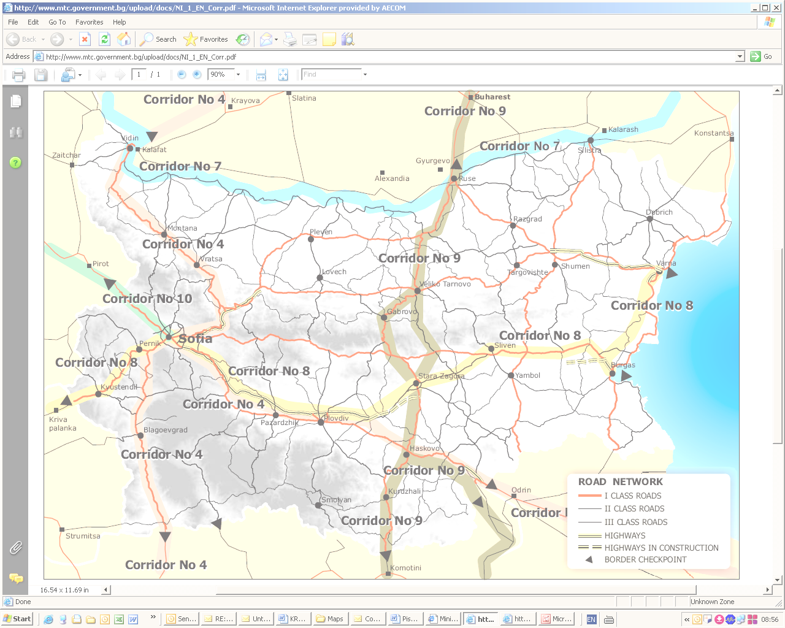
Highway links
Bypass
Figure 12. Highway transport projects

Rail projects
Figure 13. Rail transport projects

GTMP specific task is to propose projects that could be realized in short term, in particular, for the time of "Transport" OP in the period 2007-2013. Consequently, the selection of the above projects, relating to management, transport corridors and networks depends on the following key basic criteria.
Detailed information about how the individual projects correspond to the listed criteria is presented in KR 8. On this basis, list of the priority projects for short-term implementation (until 2013 is provided.
Within the EA scope are reviewed and assessed, in compliance with the planned prediction level of detail, the potential impacts on the environment, resulting from the implementation of all the options, appraised as priority in KR 8, not only the priority short-term projects for implementation, in order to achieve a higher informational extent, completeness and usefulness of the appraisal, including the expected cumulative impacts.
  - Plan relationsip with other relevant plans and programs

Whilst the transport and transport infrastructure are associated with the normal operation of all industries within the state, GTMP relates to almost everyone field of activity.
The strategies, programs and plans, relating to this plan could be divided into two groups: these which are specifically related to “transport” sector and others that have some connection with GTMP, but are not directly targetting the transport development.

- Current environmental status and possible development without the Plan implementaion
Table 17. Possible development of components and environmental factors without the GTMP implementation
- Current environmental status and possible development without the Plan implementation
Environmental components and factors |  |  | Possible development of components and environmental factors without the GTMP implementation
Climate |  |  | It is not expected a change in the trends for the component development with or without the GTMP implementation.
Atmospheric air |  |  | The GTMP planned activities are directly related to the atmospheric air quality in the settlements, and the GTMP non-implementation will result in negative changes in the existing trends for the component development (pollution of surface air in sensitive areas).  If the planned road sections are not realized, the incresing road traffic will inevitably result in pollution of surface air, increase in road accidents and congestions.  If the planned improvement of railways has not been made, the unloading of the highway traffic (if retain cargo) and the relevant reduction in emitted pollutants will not be possible.  If Inter Modal terminals are not provided, it will not be possible to combine the various modes of transport and provision for flexibility of the transport system, which will again overload the currently preferable road traffic.  The country is crossed by several transport corridors, which link the neighboring countries and/or are part of the European transport system, thus the increasing transit traffic is natural and the planned changes could only be directed towards providing passability through the organization of the relevant roads, but not by GTMP failure or approving measures to reduce the road traffic.
Water | Surface water |  | Most GTMP proposals are not directly related to the surface water and the GTMP non-implementation will not result in changes of current trends for the component development. Exceptions are the road accidents around river sections in transportation of dangerous chemical substances, the predictions for water transport, especially in the navigation on the Danube.  The navigation channel of the Danube river does not conform to the Danube Commission standards. The present conditions impose restrictions on the navigation safety, the river fleet efficiency and the capacity of the channel and river ports.  This leads to the potential threat of accidents with ships, with all consequences for the environment. If the navigation, planned in GTMP has not been implemented, the problem will worsen.  If audits of port master plans have not been made, there will impossible to identify and resolve the existing problems of water, navigation and activities, associated with the normal operation of the ports, including the environmental protection.  The problems associated with loading and pollution of water objects, due to the malfunctioning and the insufficient capacity of facilities and all infrastructure will be worsening and rising.
Water | Ground water |  | The GTMP proposals are not directly related to the groundwater regime and balance. The GTMP non-realisation will not result in changes in the existing condition of the component.  However, indirectly, the qualitative composition of groundwater, as part of a water recirculation, is related to the purity of rain water, which is infiltrating into the area of aeration (air cleanliness, waste availability) and the purity of surface water flows.  In this regard, the GTMP non-realisation will not result in impovement of the existing condition of the component.
Geological base |  |  | If GTMP is not approved and no construction is made, no additional impact will be applied on the geological base.  However, with the continuous operation of the existing facilities, will continue the technogenic influence and, if the road and rail routes are left without maintenance, rehabilitation or reconstruction, very often, especially in mountainous areas, cumulative influence will occur, which reflects on side slopes degradation, landslides of earth on the tracks, especially in rainfalls and snowfalls, occurrence of technogenic demolitions, increased erosion processes, etc.
Lands and soils |  |  | Transport infrastructure is a consumer, in a large percentage, of agricultural land, due to its communication functions between the individual settlements, which are mostly regions of arable lands. If the GTMP is not realised, this will worsen the overloading of the existing and aged transport infrastructure, its wear, respectively, the risk of unexpected incidents and contaminated sites with heavy metals and petroleum products (respectively also contamination of groundwater) and degradation of soil borders, due to the use of outdated methods for roadway maintenance.  The utilization of temporary land for commercial purposes will reflect negatively on the bordering lands - contamination by household waste, other unexpected emergencies, etc.
Landscape |  |  | Almost all GTMP proposals have a direct relation with the landscape, especially with the visual qualities of the landscape (the other natural components of the landscape are discussed in seParate sections).  Any anthropogenic interference leads to a change in the local landscape. Roads and railways form the so called. "Linear landscapes" with their own content and specificity.  Changes in the local landscape will occur whether the plan will be implemented or not.  Any infrastructure object is a terrain consumer. The disadvantages of road and railway infrastructure, and water and air transport, leading to accidents and unexpected incidents reflect on the visible part of the landscape.  The main problems are environmental, aesthetic, functional, SSAtial, economic and social.  If an integration of ecological consepts in the process of economic and SSAtial planning were not implemented, (audit of development plans for individual sectors), the problems related to the preservation and visibility of the landscape would not be solved.  This integration would ensure a maximum reversibility and elimination of disorders, increase in the function compatibility, restoration of habitats and the natural ecosystem conditions.  The utilization of temporary land for commercial purposes will reflect negatively on the visuality and aesthetic value of their surrounding environment.  The GTMP non implementation will worsen the overloading of the existing aged transport infrastructure, its wear, respectively, the risk of unexpected accidents and loss of of economic benefits.
Biodiversity | Flora |  | The GTMP non implementation (particularly for road infrastructure) will increase the overloading of the available aged transport infrastructure, respectively, the risk of unexpected accidents, contaminated areas and utilization of temporary land for commercial purposes, which will reflect negatively on vegetation in the servitude strips. It is Increasing the risk of accidents and destruction of vegetation in the vicinity or in freshwater and marine water.
Biodiversity | Fauna |  | The GTMP non implementation involves movements of road transport vehicles with low speed, increase in the noise pollution and increase in the quantity of harmful emissions into the atmosphere, around the roadway.  The GTMP non implementation will result in increased probability of accidents with the fauna representatives, accidents and risks of fires and contamination of soil and river beds.  Frequent repairs of the worn out road pavements will result in further harassment, displacement and even killing of animals.  The low share of motorways, and the lack of passages for wild animals, will increase the risk of destruction.  The absence of noise protecting screens will help to spread the noise pollution from road traffic in the open areas and disturbance of fauna representatives.  The low level of water in the Danube river creates preconditions for accidents, and the insufficient SSAce for maneuver in the Black Sea ports creates opportunities for accidents, leakage of dangerous substances and petroleum contamination, that are detrimental to the ichthyofauna.
Biodiversity | Protected areas |  | The GTMP non implementation will result in preservation of the protected areas present status.
Protected territories |  |  | The GTMP non implementation will result in preservation of the protected areas present status.
Cultural-historical  heritage |  |  | The cancellation of GTMP implementation will not result in changes in the present trends for the cultural-historical heritage development. The continued operation of ports, in current manner, will lead to progressive destruction of movable archaeological monuments (very often they are descendants of archaeological coastal sites), buried under the sediment layers, that are withdrawn under dredging activities, passage of ships in shallow water, etc.  Upon GTMP approval, using of modern design methods and implementation of control  (including preliminary studies on underwater archaeological sites, following audits of the Bulgaria”s ports), it will have an indirect positive impact on preservation of cultural- historical heritage of the aquatories.
Population and human health |  |  | The overloaded, aged and worn out transport facilities and infrastructure, and their traffic, at present have a permanent negative impact on human health. The trend will be retained if the plan is cancelled of implementation.  GTMP provides, in the most general aspect, modernization and construction of transport infrastructure, according to the contemporary requirements, at maximum reducing the transport impact on the environment and human health.  Any project, that provides for restrictive measures, regarding the negative impacts on humans, such as re-location of heavy transit traffic from the settlements by bypass roads, noise protecting screens, etc. has the potential to positively affect the human health factor.
Risk of incidents |  |  | The increasing amortization of roadways, the technical parameters of the old roads, not not meeting the load requirements for the road class, the absence of bypass roads to many populated areas, that inserts the heavy transit traffic into populated areas, are conditions for road accidents with severe consequences both for humans and animals.  Many of the stationary obstacles (trees, posts, etc.) are neighboring the active traffic routes, so that the slightest deviation of the driver attention, results in a blow into the stationary obstacle.  The disadvantages of the road infrastructure, old cars with low rate of passive and active safety, lack of adequate road markings, combined with low traffic culture, and lowered traffic control will result in increase in the number of car accident victims.  In rail transport, the main problem is the old rolling stock and infrastructure. Modernization is extremely required to improve the road safety.  The non-implementation of the plan, in terms of the proposals for water and air transport, will result in a change of the current trends for accidental risks.
Tangible assets |  |  | The GTMP non-implementation will result in retaining of the trend, related to the old and amortized, not meeting the standards and requirements for transport infrastructure, which in turn will reflect negatively on other factors, and on the environmental components.
Waste |  |  | The aged and unmaintained road infrastructure contributes to the accelerated amortization, frequent accidents, and last but not least, the increase in the disused motor vehicles.  The present available facilities for collection and treatment of waste from ships and port activities are insufficient and do not meet the necessary requirements, thus creating an unacceptable risk to the environment. Without GTMP implementation and in particular – option W08 - treatment of liquid and solid wastes, the problem will be worsening.
Transportation of dangerous goods |  |  | The cancellation of GTMP implementation will not affect the existing trends in terms of "dangerous goods" factor.  Similarly to waste, the aged and unmaintained transport infrastructure leads to increased frequency of accident situations in the road, rail and water transport.
Harmful physical factors |  | Noise and vibrations | In non-realisation of the planned bypass roads, the noise loading problem will be worsening.
 |  | EMF | The GTMP implementation/non-implementation is not related to EMF.

- Characteristic of the environmental areas that likely to be significantly affected
The following sensitive/ vulnerable areas are defined:
- Characteristic of the environmental areas that are likely to be significantly affected
A. Regions for atmospheric air assessment and management (RAQAM)
After 1999 there is a tendency to reduce the emissions of harmful substances into the atmosphere.
In territorial aspect, the country’s industry is concentrated within and around densely populated areas. Thus, are formed industrial regions, which are characterized by a relatively higher level of emissions, compared to the rest of the country, and simultaneously air pollution with several types of harmful substances
Traffic is the major contributor to this pollution in the densely populated areas, especially by nitrogenium oxides and particulate matter.
The distribution of harmful substance emission throughout the country is registered by the Regions for Air Quality Assessment and Management (RAQAM) of the National Automated System for Atmospheric Air Quality Monitoring (NASAAQM) in MEW.
The RAQAM locations, related to the GTMP planned road sections, are given in the following figures. It could be seen that most of these road sections pass through these regions; and nevertheless that they are contributiIing to pollution, they are also expected to have a positive effect, due to taking and re-location of road traffic beyond the densely populated districts .

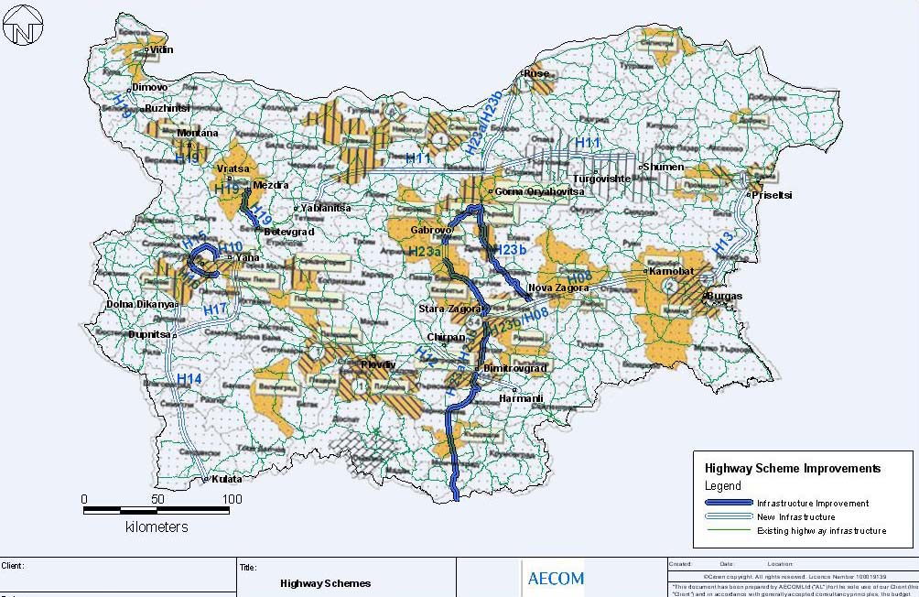
Figure 16. Location of RAQAM (EEA 2003) with excessive levels of nitrogenium oxides (NOx) and their highway arteries
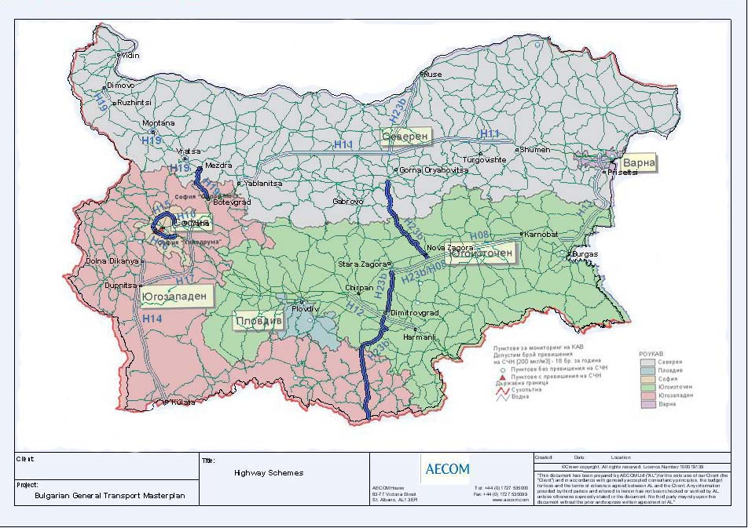
Figure 16a. Levels of dinitrogenium oxide pollution in the united RAQAMs (EEA 2007) and their highway arteries
Under the assessments, performed in 2007, the excess levels of AHR and AAR dinitrogenium oxide was registered only in RAQAM Sofia, as a basic source of transport emissions.
During the year AHR + LAT was disturbed only by more than 18 average hour values above 230 µg/m³ registered. In registration of LAT during the year, excess of AAR (46 µg/m³) was registered only in "Eagle Bridge" AIS - traffic-concerned station). In the other RAQAMs throughout the country, in 2007 there was no exceedance of dinitrogen oxide emissions in the atmospheric air, i.e., the registered number of exceedances of the limit values are within the admissible limits or these are absent.
(National Report on the status of environment and its protection, in the Republic of Bulgaria, 2007).
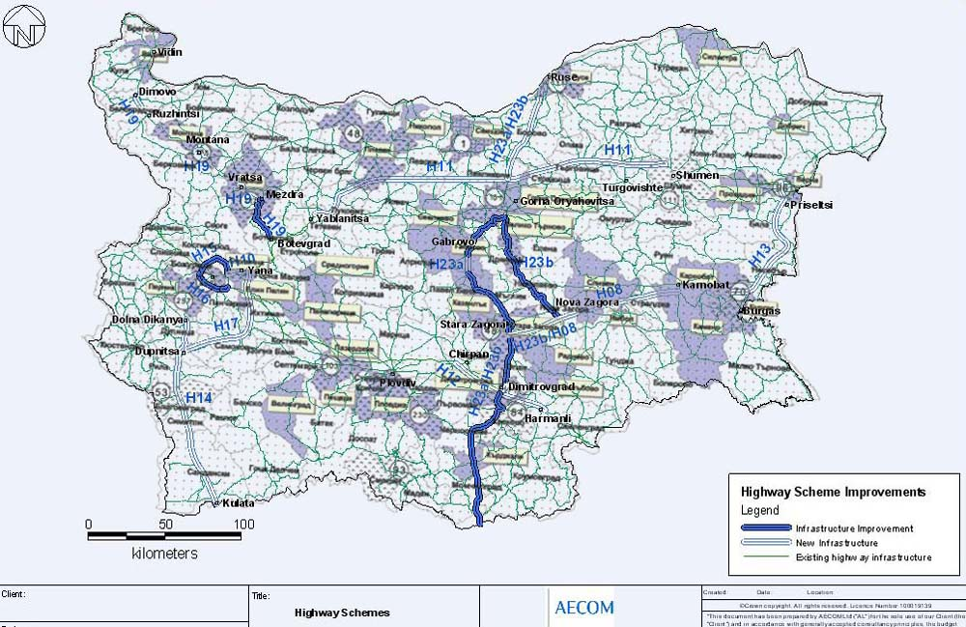
Figure 17. Location of RAQAM (EEA 2003) with excessive levels of fine particulate matter (РМ₁₀) and their highway arteries
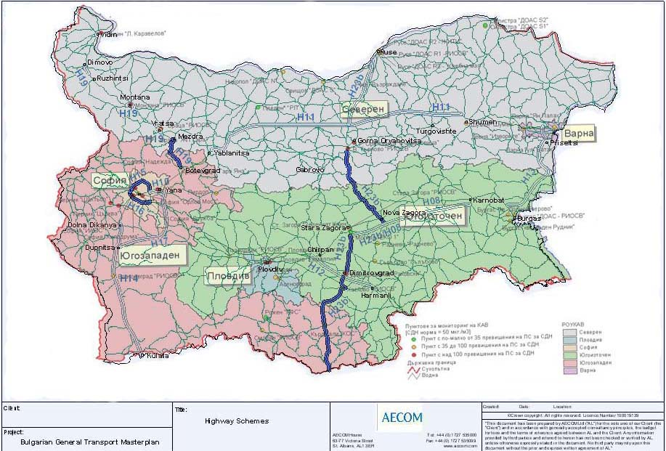
Figure 16a. Levels of PM₁₀ pollution in the united RAQAMs (EEA 2007) and their highway arteries
The PM₁₀ pollution is remaining a major problem for the air quality in all RAQAMs. In 2007, the Average 24-hour norm of PM₁₀ was disturbed in all RAQAMs with registered more than 35 average 24-hour values above RV+UAT for PM₁₀ (55 μg/m3).
The source of the registered excessive pollutions are the industrial, household and transport operations on the relevant municipality territories, as well as the durty and poorly maintained road surfaces.
(National Report on the status of environment and its protection, in the Republic of Bulgaria, 2007).

B. Sanitary Secured Areas
The Sanitary Secured Areas are part of the water protected areas and are designated under WA and Regulation No 3 on the conditions and procedures for study, design, approval and operation of SSA around water sources and facilities for drinking-household water supply and around sources of mineral water, used for therapeutic, prophylactic, drinking and hygiene needs. They are established around water-taking surface and ground water objects, and are related to preserve the quality and quantity of water, used for drinking-household water supply.
Due to the overall level of planning, on which GTMP has been prepared, at this stage there are no established routes for highway and railway construction , and it is impossible to define whether they will affect SSA.

C. Geological base
It should be emphasized that in the design of transport infrastructure, it is essential to conduct engineering-geological and hydrogeological studies. The anthropogenic impact on the geological base, should consider the risky geodynamic processes and events and the consequences of their occurrence.
D. Flora
The permanent negative effects on vegetation under the construction works are seen in direct destruction of plant communities of a different nature on the territory of routes and their servitude areas.
There is also a possibility for destruction of protected plant species, not involved within the protected areas and territories, and changes in the natural composition of vegetation, bordering the routes.
Another possibility for adversely affect on the flora changes are the abiotic environmental factors, that could result in loss of individual species on the account of another ones and a long lasting change in the community nature.
The plant biocoenoses are affected by the invasion of species, inappropriate for the relevant habitat. The subsequently arisen inter and between-species-competition could also cause their destruction.
Despite small, there is a probability of fire occurrence and vegetation destruction (especially in forests), due to non-meeting the technological and labour discipline by irresponsible operators. The latter possibility could be excluded, under a strict control implementation.
E. Fauna
The projects impact could cause direct destruction of nesting, food habitats, habitats for rest, shelters, etc. Due to changes in the other environmental components (lighting, noise, vibrations, hydrological changes) could occur reversible or irreversible changes in the characteristics of the species inhabited areas.
Birds, invertebrates, amphibians, reptiles, bats and some small mammals often become victims of road traffic, which leads to changes in the structure and size of their populations.
For certain species, undertaking daily or seasonal migrations, roads can be an irresistable barrier, including the free genetic/reproductive exchange between their populations.
F. Protected areas and territories
and habitats. The introduction of new categories and standards (under the jurisdiction of international institutions) will require a change in the mode of use, maintenance and exposure of natural values.
For each category, the protected areas and territories have certain restrictive requirements, which must not be breached or changed.
The transport corridors, such as roads and railways are a major cause of habitat fragmentation. They do not only destruct the natural habitats, because they occupy the SSA, but also worsen the quality of neighboring areas, for example by pollution, noise, hydrological impacts and light pollution. Besides, the transport corridors impede the movements of land animals on the terrain, which may result in increasing isolation of their populations. Finally, but not least, the roads increase mortality in wild animal populations, as a result of collisions with vehicles.
All these impacts may increase the risk from (local) extinction of some species, especially of those which are already vulnerable or endangered. The roads could cross important habitats and restrict the movement of wildlife between habitats on both sides of the road.
As a result, small groups of animals might become relatively isolated, which is reducing the probability for their survival. The road physical characteristics could be invincible barrier for some species, others may themselves avoid the road and all its related harassments.
The GTMP projects should be eligible for implementation, only when is does not breach the regime for protected areas and territories management, under the orders for their designation and the management plans. For this reason, BDA provides, within the procedure for compatibility assessment, eligibility check of specific investment proposals, plans, projects and their programs.
The legislation provides that the expected negative impacts on protected areas should be reduced, restricted or prevented by applying a specific set of measures that are mandatory for execution.
In cases, where projects are of exceptional public interest, despite the significant damage to protected areas, their implementation is possible, if adequate compensatory measures are undertaken before the commencement of their construction.
G. Problematic areas for wildlife in the road network and priorities for planning of long-term defragmentation measures
Since it is a serious environmental problem, in 2006 -2008 on the territory of Bulgaria was made a study, as a result of which in 2008 was created a project for RESTORATION OF ECOLOGICAL NETWORKS ON TRANSPORT CORRIDORS IN BULGARIA (identification of problem areas and practical solutions) .
The report on the study presents the situation in the country, related to the extent of fragmentation of natural habitats in transport corridors, identifying the priority stations at national level, and showing the locations, that are most needed for planning of long-term defragmentation measures. It gives recommendations for the implementation of concrete measures to mitigate the negative road and rail infrastructure impact.
It was found that the existing and planned new road and rail networks could be reconciled with the development of coherent ecological networks by undertaking appropriate actions to build a crossing facilities and safety borders.
Thus, the issues for biodiversity preservation should be taken into account at the earliest transport planning stages. This study identifies and prioritizes the sections of highway and railway network in Bulgaria, for which it might be necessary to mitigate the negative consequences, and provides recommendations for prevention or mitigation of damage in the problems identified.
The identification of problematic sections on highway and railway network in Bulgaria is made through combination of two strategies.
First strategy - an expert model, based on GIS (Geographic Information Systems), has been used to study the anthropogenic impacts by the existing and planned transport corridors on the viability of wild animals populations.
Second strategy – consultations with experts on the matter, concerning the more important problematic areas in the transport network, according to their points of view. Since it is impossible to provide analysis on all the species in Bulgaria, that are sensitive to road impacts, twelve key species of wild animals have been selected, which are used as indicators for the appraisal of problematic sections in the the country’s road network.
They are selected 8 species of mammals, 3 species of reptiles and 1species of amphibians: Brown Bear (Ursus arctos), Wolf (Canis lupus), Deer (Cervus elaphus, Wild cat (Felis silvestris, Marten (Martes martes), River otter (Lutra lutra ), Marbled Polecat (Vormela peregusna), Hamster (Spermophilus citellus), Aesculapian Snake (Zamenis longissimus), Ground squirrel (Spermophilus citellus), Aesculapian Snake (Zamenis), Marbled snake (Elaphe sauromates), Turtles (Testudo hermanii and Testudo graeca) and Toad (Bufo bufo).
The identification of total 283 problematic sections require to assess which sections need the most urgent measures to be undertaken. The map shows the priority degree of each problematic section, designated on the basis of the expected growth of population viability and eduction in wildlife mortality, due to collisions with the road vehicles, when the measures to mitigate the adverse impacts of the road are implemented. Around 30% of all problematic sections are with high priority. For these places are recommended immediate actions to be taken, as the highway or railway barrier effect there is high, or the wild animals often find their death in traffic. The problematic sections distribution, according to the priority classes, is as follows:
- High priority - defragmentation measures to be taken before 2015
- Medium priority - defragmentation measures to be undertaken before 2020;
- Low priority - defragmentation measures to be undertaken before 2025.
H. The Black sea protected areas
The Black Sea area is one of the most sensitive areas in Bulgaria, in terms of ecological balance
It has a complex of negative impacts of natural and anthropogenic nature - strongly over-developed, continuous abrasion impact on the coast, presence of landslide areas, especially in the northern Black Sea region, aged, amortized and inadequate infrastructure and port facilities.
In relation to the structure and the solution of problems on the Black Sea region, the special Black Sea Coast Structure Act has been adopted.
On the Black Sea coast territory are defined the following security areas:
- "A" Area with a regime of special area structural protection;
- "B" Area with specific territory characteristics and special regime of territorial and aquatic resources protection;
I. Noise loading
The limit values of noise, in different territories and structural areas in the urbanised territories and beyond them, are normed by Regulation No 6 on the environmental noise indicators and determine the boundaries of protected areas.
J. Cultural-heritage sites
The physical demolishion of archaeological sites, during the construction works, requires the consistent implementation of measures for their registration and research. They are legally regulated in the Cultural Heritage Act (CHA) (art. 160-161) and the Regulations on Execution of Archaeological Research on the Territory of the Republic of Bulgaria (RCARTRB – SG, issue 12 / 1997).
The archaeological research is an integral part of the activities, preceding the issuance of construction permit.
K. Hygiene-protected areas
During the construction and operation of transport infrastructure, must obligatorily meet the regulatory requirements for hygiene secured areas of the settlements. The detail of the plan does not, at this stage, allow to indicate any further breaches of HSA, resulting from the plan implementation.

- Existing environmental problems, identified at different levels, relevant to the plan, including these related to areas of particular ecological importance, like the protected areas under Biological Diversity Act
- Existing environmental problems, identified at different levels, relevant to the plan, including these related to areas of particular ecological importance, as the protected areas under Biological Diversity Act
Environmental components and factors |  |  | Environmental problems | Relation to transport
Climate |  |  | Global warming. | Greenhouse gas emissions from transport vehicles
Atmospheric air |  |  | Air pollution with harmful substances above the permissible norms. | Harmful emissions from transport
Water | Surface water |  | Loading with harmful and biogenic substances;  Utilization of the living environment and access to nutrients for aquatic organisms, and therefore- the ability to survive;  Contaminated water at the ports and neighboring aquatories.  Hydro-morphological changes in surface water. | Dredging and construction activities at ports;  Navigation on the Danube river;  Poor state of inter-port transport infrastructure;  Insufficient port facilities for reception of wastes from navigation activitiy;  Construction of bridges and correction of river beds in the road transport.
Water | Ground water |  | Local contamination of groundwater due to accidental spills. | Transportation of dangerous goods.
Geological base |  |  | Appearance of geodynamic processes and events: landslides, demolitions, degradation, erosion, collapse, rock pressure. | Construction of roads, railways, bridges, retaining walls, which is associated with conducting of excavation and backfilling works, dug of slopes, geological redistribution of load, change in the tense state of the massifs.
Lands and soils |  |  | Utilization of high-productive lands;  Soil degradation;  Erosion processes;  Contamination by dust and pollutants, emitted by transport, on terrains, neighboring to the roadway.  Accidents involving spills of petroleum products. | Utilization of land for transport infrastructure;  Unimplemented re-cultivation;  Construction and operation of transport infrastructure;  Neglected and defective transport vehicles;  Transportation of dangerous goods.
Landscape |  |  | Reduction of natural, natural landscapes;  Changes in visual appearance; | Formation of linear landscapes;
Biodiversity | Flora |  | Utilization of territories.  Air pollution with harmful substances above the permissible norms;  Change in the habitat of hydro-biontits, due to correction, endigging and straightening of river beds and drainage of the marshes;  Run-off and drainage of wet and marshy areas and the related shallowing of rivers;  Deterioration of rivers and beaches, destruction of the reproductive areas of ichthyofauna species  Destruction of habitats, due to uprooting of wood and bush vegetation in the forest fund;  Change in the natural habitats, due to establishment of green belts of tree and shrub species, alien to the region. | Occupation of areas by transport sector;  Unfavorable age structure of the fleet;  Change in the natural character of land, construction of road facilities;  Destruction of habitats of amphibians, change in the habitats of ihtiobiontits;  Extension of ports and terminals;  Construction of transport infrastructure.  Re-cultivation, following the infrastructure facilities construction.
Biodiversity | Fauna |  | Destruction the habitats of hydrobiontits in dredging the bottom of the Danube and the seabed within the port boundaries.  Direct extinction of animals, their eggs and larvae during the construction works;  Direct destruction of habitats for some animals, during excavation and backfilling operations, destruction of soil communities in the removal of surface soil layer;  Fragmentation of wild animals populations, harassment and displacement of animals, due to increased human presence and repeated vehicle passages.  Injuries and killing of animals by road vehicles;  Increased aviation noise, harassment, displacement of animals in the areas surrounding the airports;  Direct killing of birds under incidents at airport runways.  Light pollution and displacement of wildlife, in the road lines areas.  Harassment and displacement of wildlife during construction and operation of roads. | Extinction and displacement of animals, destruction of their habitats during the extension of sea and river ports, and the construction of shelters for river ships.  Execution of excavation and backfilling operations, disposal of land masses;  Construction of transport infrastructure  Absence of standards for design of road facilities, to allow free access of all groups of animals to the neighbourin areas and free exchange of genes.  Road network and increase in traffic.  Air traffic  Air traffic  Road traffic  Amortized road infrastructure and increased traffic on it.
Biodiversity | Protected areas |  | Reduction of area and loss of habitats;  Fragmentation of wildlife populations. | Allotment of lands for the construction of transport facilities and linear objects;  Absece of standards for design of road facilities, to allow free access of all groups of animals to the neighbourin areas and free exchange of genes.
Protected territories |  |  | Reduction in the area and loss the value of natural areas. | Allotment of lands for the construction of transport facilities and linear objects;
Cultural-historical heritage |  |  | Involvement and destruction of CHH sites. | Construction of transport infrastructure and facilities;
Population and human health |  |  | Increased population morbidity;  Exposure of population to high noise levels. | Loading by transport.
Risk of incidents |  |  | Incidents and accidents;  Transport accidents and incidents, leading to victims, and pollution of water, vegetation and soil. | Poor state of infrastructure, leading to large number of accidents.
Tangible assets |  |  | Aged and amortized transport facilities and infrastructure. | Poor maintenance and monitoring of transport facilities;  Insignificant investment in tangible assets with ecological use;
Waste |  |  | Diffuse dumping sites;  Contamination of roadside sites with household waste.  Shortage of waste treatment facilities;  Reduced control of purity and lack of adequate sanitary facilities, and locations for waste throwing along the road lines.  The facilities for prevention and control of pollution, including collection and treatment of waste from ships and port operations are inadequate and create an unacceptable risk to the environment. | Contamination of roadside sites by household waste.  Shortage and lack of treatment facilities for ship waste at ports.
Transport of dangerous goods |  |  | Incidents and accidents with dangerous goods. | Poor state of infrastructure, leading to large number of accidents.
Harmful pkysical factors |  | Noise and vibrations | Exposure of population to high noise levels. | Loaded transport traffic, especially in the residential regions.
 |  | EMF | Exposure of population to EMF. | The relationship with transport could not be designated uniquely, as the impact of EMF on the telecommunication equipment is not clearly assessed and addressed.

- GTMP objectives for environmental protection at national and international level
- GTMP objectives for environmental protection at national and international level
The objectives of the environmental protection at national level are defined in the basic strategic document of the Republic of Bulgaria, related to the environment - National Environmental Strategy (NES), 2009-2018. The six strategic objectives for the environment and the way they have been considered in GTMP development, are presented in the EA Tables. The conclusion is that OGPT contributes to achieve some objectives and does not contradict anyone of the of the strategy goals.

Formulation of GTMP objectives for environmental protection
Primary environmental objective: Sustainable transport development
Specific environmental goals:
- Balance the development of different modes of transport by increasing the share of rail transport, aimed at limiting the harmful emissions by transport
- Integrate the environmental requirements in the plans, programs and projects for transport development;
- Limit the noise load in populated areas and its adverse effects on their inhabitants, through the allocation of transit traffic into bypass routes;
- Reduce the water and port areas pollution from ships, through auditing of general master plans, in terms of compliance with the environmental requirements, and introduce a waste management system.
The indicated goals must be considered and developed in detail, at the design stages of the specific sector investment proposals for "Transport" sector.

”

- Possible significant environmental impacts
In the tables and matrices in it. 6 are present only the projects, related to activities, whose implementation will, to some extent, directly or indirectly affect the environment, and which are associated with construction and/or rehabilitation.
- Possible significant environmental impacts
- Air
The road traffic is the major air pollutant. The exhausted emissions have also a cumulative impact on this component, resulting also in the polluted air basins in Bulgaria, identified by EEA (Environment Executive Agency).
The projects proposed in GTMP have a positive impact on air, since their implementation will improve the infrastructure, which in turn will allow an optimal regime of vehicles traffic, reducing at maximum the release of harmful emissions. Re-location of the heavy transit traffic away from the settlements, through construction of bypass road routes, is the best way to reduce the air pollution in them, and partucularly, where there are additional loads of industrial emissions.
The risk of negative impact on air could be considered admissible.
- Water
Transport is not associated with surface and groundwater in the capacity of their user. It is not either related to generation of wastewater.
The contaminations that it could cause are result of incidental events, careless attitude towards technology discipline or a lack of control on the owners and/or users of transport traffic in all its diversity - Motor vehicles, railway rolling stock, ships and aircraft.
It could be expected a negligible negative impact.
- Geological base
In construction of new infrastructure facilities in the route track, the geological base is irreversibly destroyed.
Transport infrastructure is composed mainly of linear engineering facilities (tracks), mainly surface, which have a very small width and therefore, they affect a very small area of land.
The construction and operation themselves are not related to the use of underground resources, valuable mineral resources or large-scale activities, related to damage of ground surface or operations in the geological base depth.
More serious impacts could arise only in tunnel operations, which have not been identified in GTMP, in fact they have been rejected, as less acceptable (the tunnel under Shipka ).
The impact could be considered admissible.
- Lands and soils
In construction of new infrastructure facilities, the land and soils within the route trace are destroyed, and these within the servitude strip are damaged and change their purpose.
Since the linear engineering facilities (tracks) have a small width and therefore, affect a small area of land, the impact can be considered negligible. The re-cultivation projects of the affected areas, will further reduce the adverse impact imposed.
The impact could be considered admissible.
- Landscape
In any type of construction, including transport infrastructure, the landscape is always changing. Even not changing its nature, the infrastructure has an impact on the visual scope.

In the landscape projects implementation, the visible negative impacts are mitigated. By spreading of future plant groups, is enabled the adaptation of fauna representatives to the newly created conditions and landscapes.
The impact could be considered admissible.
- Biological diversity
- Flora
In the projects implementation, during construction, the vegetation is destroyed in the route track and in the servitude stripes. The same negative impact is imposed within the bordering construction line, particularly when it crosses forest areas.
After the construction works completion, through appropriate re-cultivation and landscape projects, the initial negative impact could be limited and highly reduced.
As a whole, the impact of the projects proposed, in meeting the set out measures, could be considered admissible.
- Fauna
The construction works in the region area have a high negative impact on fauna, destructing its habitats and displacing other animal species, due to their harassment.
After construction of the linear transport structures and its commissioning, a secondary succession of animal species could occur, as well as creating of new habitats in the re-cultivated lands within the servitude.
The most serious outcome of the infrastructure projects is the fragmentation of habitats, which could be higly reduced by construction of appropriate facilities for animal crossings.
Using the best practices, following the specialists recommendations, combined with the model for defining the problem sections for various animal species, will acceptably mitigate the negative impact of transport on this component.
- Protected areas and protected territories
The GTMP projects should be eligible for implementation, only when the regime for management of protected areas and territories, declared by the Ordiances on their designation and the management plans are not breached.
For this purpose, BDA intends that within the compatibility assessment procedure, should be performed a compatibility assessment of the specific investment proposals, plans, projects and programs.
The legislation envisages that the expected adverse impacts on protected areas could be reduced, restricted or prevented by implementing a specific mandatory set of measures.
In cases where projects have exceptional public interest, despite the significant damages to protected areas, their implementation is acceptable if adequate compensatory measures are undertaken, prior to their construction.
- Cultural-historical heritage
The main impact on the historical-cultural heritage arises during the construction on archaeological sites, which are often not registered at the initial stage of construction. Meeting the established requirements for review of the site by archaeologists, at EIA level of feasibility studies, as well as their walking on the already laid route and their presence during the construction, at high extent will provide for the identification and survival of archaeological artifacts.
In compliance with all requirements set by the regulations and meeting the recommendations at EIA level, the impact of transport, and in turn- of GTMP could be considered admissible.
- Population and human health
Any project that leads to reduction of transport loading in cities, where the noise impact and air pollution is the most sensitive and with the most severe impacts on the population, could be regarded as affecting the human health positively.
GTMP proposes some options to re-locate the heavy transit traffic beyond the settlements, as well as the implementation of new projects, using noise protecting screens to reduce the noise impact on populated areas of settlements.
The noise impact by GTMP implementation could be considered admissible, on condition that are avoided routes in close proximity to recreational and treatment areas, where the installation of noise protecting screen could not be ensured.
- Risk of incidents
In its large part GTMP is essentially aimed at improving the existing and constructing a new and modern transport infrastructure, compliant to the modern requirements, which will reduce the risk of accidents, in terms of machines.
The educational programs and information solutions will also reduce the human factor risk.
GTMP has a distinctive positive impact on the risk of accidents in any aspect.
- Tangible assets
The impact on tangible assets, in compliance and implementation of the measures set out in it. 7 of the Preliminary Environmental Assessment, as a whole, could be summarized as positive, because the priority projects for transport development will result in construction of modern infrastructure objects and facilities, some of which are tangible assets with ecological use (systems for treatment of port waste, envisage of passes for animals, etc.).
- Waste
Transport infrastructure is not relevant to this component, except for during construction, where the excavation works and identification of disposal sites for the dug earth and rock masses are needed to be fixed. As long as there are many sites, such as abandoned quarries, the disposal could not be regarded as a serious environmental problem or typical pollution.
Wastes are not generated as a result of transport operation.
Transport is not a source of permanent waste, by types and quantities. In meeting the requirements of Traffic Act, regular cleaning of infrastructure facilities and technological requirements for collection of waste from ships, cars or railway rollong stock, related to transportation of different types or quantities of waste, the impact on this component could be be defined as admissible.
- Transportation of dangerous goods
The use of reliable transport vehicles, meeting the requirements for transportation of dangerous goods and the control of loading-unloading operations, will highly reduce the potential for adverse impacts on the environment, due to accidents and incidents related to their transportation.
GTMP suggests modernization of transport and infrastructure, which will indirectly have additional positive impact on reducing the risk of incidents with dangerous goods.
- Harmful physical factors
The main adverse transport impact is caused by the operation of transport infrastructure.
There are many possibilities and methods to reduce the noise load in the regions of road routes. In designing the necessary noise protecting screens, the impact could be reduced to admissible load levels, in compliance with the regulations.
In designing of appropriate noise protecting facilities, the GTMP projects will not have a significant impact on this component.

- Measures, envisaged to prevent, reduce and most efficiently compensate the adverse impacts on environment, resulting from the Plan implementation
- Measures, envisaged to prevent, reduce and most efficiently compensate the adverse impacts on environment, resulting from the Plan implementation
А. Measures to be included in the Final GTMP version

The following terms and measures should be included in the Final GTMP version:
- Compliance with the environmental protection regulations and legislation;
- The projects, providing investment proposals/plans, for which EIA/EA is required (under EPA) and/or assessment for compatibility (CA) of the project with the object and purpose for preservation of protected areas, which are likely to be affected, must be approved only after a positive EIA/EA opinion and/or CA descision, and meeting the recommendations in the assessments made and in the decisions and opinions presented.
- In the itself stage of feasibility studies on road or railway routes, should be used updated maps, on the base of which, the proposed options should be fitted with the existing infrastructure, already constructed by other institutions and agencies.
- For each project location should be proposed and considered options, that are consistent with the regimes for use of protected areas and protected territories, preservation of CHH, meeting the requirements for HSA and SSA, avoiding additional load on the air in RAQAM;
- During the design of roads and railways, in the phases of feasibility studies, should be considered the results of the study on problematic wildlife areas of the road network (project on RESTORATION OF ECOLOGICAL NETWORKS THROUGH TRANSPORT CORRIDORS IN BULGARIA (Identification of problematic sections and practical solutions), in order to include, in individual option developments, projects for construction of facilities for animal crossings;
- In selection of options for the relevant priority project implementation, should be preferred those that have minimum impact on hydro-morphological condition of water objects. If possible, the options related to correction of riverbeds, and those passing near the water mirrors of dams, marshes and lakes should be avoided.

B. The measures to be considered in development of priority projects involved in GTMP are indicated in the table below:
Component/Environmental factor | Measures | Term/ implementation stage | Contractor | Reasons
General measures | 1. Comply with the conditions and measures in EIA Decisions, adopted by the EIA and Priority projects compatibility assessment, to be included into the Construction Organization and Execution Plan (COEP)  2. The relevant regional forest departments will be involved in the stages of concrete projects development. | Construction and operation | Investor, Monitoring authorities  Design | Limit the impact on the environment  Consider RFD and forest fund preservation
Atmospheric air | Consider the options for location of road infrastructure with the indicators for atmospheric air quality.  Modeling of transport emissions distribution and their maximum taking off from the settlements. | Conceptual design | Investor | Acquire information for underaking measures to reduce the impact on atmospheric air
Water | 1. During the auditing of master plans for port development, should be assessed the ecological condition of aquatories, cumulative impacts and their total loading by the anthropogenic activity.  2. Prior to the commencement of operations for solving the navigation problems, should be prepared geodesic prifiles of the bottom, study of hard runoff, hydraulic and hydrological calculations, that will enable the future operations.  3. The activities planned in GTMP should comply with the results and the program of measures to achieve good status of water objects in the plan for river basin management, relevant to the respective basin region, implement ing the activity.  4. In the specific projects development, during the EIA procedure, should be considered the existence (or not existence ), near the investment proposal route, of water objects- sanitary secured areas, surface water flows, condition of grounf water object and the expected possible negative impact from the operation implementation.  5. In the specific projects development, after a full analysis on the water resources and the impacts on them, should be set measures to protect the water from pollution and depletion.  6. In taking water or use of water object, the relevant permits under Section IV of Water Act should be received.  7. In EIA preparation for specific projects, they should be submitted to the relevant Basin Directorate for introduction and issuance of statement. | 1., 2. Auditing  3. Feasibility studies  4. Feasibility studies  EIA procedure  5. Design, EIA  6. Prior to construction works  7. EIA | 1,2. Investor  3. Investor  4. Investor, expert team preparing EIA  5. Investor, expert team preparing EIA  6. Investor  7. Investor | Consider the development of ports with the natural capacity of aquatory areas  The study results will show whether special measures to limit the impact are needed  3. This measure is proposed in compliance with the recommendation of BD - the Danube region in their letter and will lead to achieving the objectives for better status of water objects  Measures 4 - 7 are proposed in compliance with the opinion of BD Eastern Region and will lead to water protection.
Geological base | 1. The engineering and geological studies of the old projects should be updated and new engineering and geological data should be used for the new route projects.  2. During the feasibility studies, should be conducted preliminary studies on the presence, in the route region, of registered deposits of underground natural resources. | Feasibility studies | Investor | Consider the geological characteristics, and the presence of underground natural resources in the choice of routes, and prevent the activation of landslide processes and their impacts on ground water
Lands and soils | 1. In selection of options for implementation of the relevant priority projects, should be chosen the schemes, providing the expropriation of unproductive agricultural land (above V category) and low ploductive soils, and at maximum rate, should avoid possible forest lands.  2. Develop projects for re-cultivation of lands, damaged as a result of construction of transport infrastructure.  3. During the operation of transport infrastructure and its facilities, should be provided measures to prevent the deterioration of soil quality in the servitude of road routes in any emergency spills of dangerous substances and petroleum products  4. The projects for rehabilitation of road infrastructure and these for construction of new infrastructure should plan the afforestation of slopes, in order to be stabilized and prevent from erosion. | 1. Feasibility studies  2. Detailed design  3. Operation  4. Detailed design | Investor | Rational use of land  Soil protection from emergency spills of dangerous substances
Landscape | Develop and implement infrastructure projects through greenery landscape shaping. | Design, implementation after the construction works completion | Investor | Mitigate the impact, resulting from the change of landscape type
Flora | 1. Make floristic studies within the boundaries of the routes, planned for construction of transport infrastructure and facilities.  2. Use the information related to the floristic surveys on the ongoing monitoring of forest ecosystems and that on the health status of forest ecosystems.  3. Avoid the areas occupied by protected habitats, whose main purpose is to preserve the natural vegetation, landscape and biodiversity, and their protection.  4. Avoid routes through areas occupied of highly productive forests, resistant to harmful influences.  5. Involve, at the beginning of feasibility studiy on a specific investment proposal, related to transport infrastructure, experts-biologists, who, on the basis of the existing monitoring results (Protected areas and territories, BDA and PAA), should provide competent recommendations on the future routes, and on EIA an EA level- concrete measures for protection of populations and habitats of protected animal and plant species. If necessary, select a new route, in order to preserve the protected species, which should include:  - indicate the habitats and declare them as protected  - organize effective measures for their protection  6. With regards of protected plant species - greater risk of destruction arises during the construction of individual objects. Observe the restrictive construction ines, to avoid further damages on terrains and their vegetation.  Within the specific investment plans should provide measures, where necessary, for relocation of individual protected plant species and their planting in appropriate areas. Provide compensatory programs for the destroyed vegetation. | Pre-investment  study | Investor | Preserve the valuable plant species communities
Fauna | 1. In the design of priority road and rail transport projects, should be studied the suitable sites and considered facilities for the safe passage of wildlife.  2. In proceding of EPA investment proposals, related to the operation of the Danube as a waterway, a prior monitoring should be prepared by ihtiobiologists to identify the breeding/ reproductive areas (areas for caviar discharge) of sturgeon and other protected fishes and provide concrete measures for their protection in dredging works.  3. Ensure tight control over the condition of navigating vessels and port facilities for various types of cargo, to prevent the leakage of chemicals into the waters, affecting the water quality and threatening the existence of the already highly depleted populations, particularly of sturgeon fish. | Pre-investment  study | Investor | Limit the fragmentation of habitats
Protected areas and territories | Feasibility studies on the availability of protected territories (PTA) and Protected Areas (BDA) and compliance with them of the options on location the road route infrastructure. Maximum distance from:  - territories, designated as habitats or species protected areas - the Natura 2000 sites, declared under Directive 92/43/EEC on the preservation of natural habitats and wild flora and fauna, and Directive 79/409/EEC on the wild birds preservation;  - vulnerable and sensitive areas;  - areas for preservation of valuable commercial fish species and other aquatic organisms;  - protected territories and areas, designated for preservation of habitats and species, where the maintenance or improvement of water condition is an important factor for their protection. | Pre-investment  research | Investor | Preserve the protected areas, fragmentation of habitats and populations
Cultural- historical heritage | 1. In order to be most effective, the archaeological field work on specific routes should be performed during an appropriate season: in early spring (before the active season of vegetation) or in autumn, after the farm works competion.  2. In organization of sites for storage of excavated earth and rock masses, should be explored the sites, where these will be deposited.  3. Underwater exploration must be performed prior to dredging and construction operations within the ports. | Project and  construction  (if object is available) | Investor, professional archaeologists | Exclude the possibility for burying or destruction of archaeological sites and findings
Population and human health and noise | Plan and implement appropriate noise protection screens for the relevant project, based on the expected noise levels. | Technical and detailed design | Investor, Designers | Limit the impact on human health and reduce the noise load
Waste | 1. Prior to the dredging works for the execution of navigation on the Danube River and on the navigational operations in the ports of Burgas and Varna, should be studied and selected suitable sites for the disposal of dredged masses.  2. Suitable disposal sites for the excavated earth and rock masses from the construction of road and railway infrastructure should be approved.  3. Regular cleaning and maintenance of road infrastructure, including the drainage facilities around the roads should be performed. | 1.Pre-investment study  2. Operation | Investor, Municipalities,  Monitoring bodies | Prevent from waste pollution

- Description of reasons for selection of alternatives and methods to perform the environmental assessment, including the difficulties in collection of the required information, regarding technical imperfections and lack of know-how
The selection of the final options/projects for transport development, discussed in it. 6 of EA, and the designation of priority projects for short-term implementation, proposed by GTMP, have been developed, using the 4-stage appraisal procedure, and the appraisal framework is presented in KR 5.
- Description of reasons for selection of alternatives and methods to perform the environmental assessment, including the difficulties in collection of the required information, regarding technical imperfections and lack of know-how.
The Appraisal framework includes a lot of names, covering the following key indicators:
- Benefits and costs;
- Economic growth contribution;
- Social benefit-coast analysis;
- Environmental impact;
- Contribution to balanced regional development
- Impact on transport safety and security, and
- Relation to other projects.
KR 8 sets out the proposal for GTMP general strategy and determines the priority projects that should be considered as an onset of its realization. The Report is based on the analysis, presented in the KR 4, providing a long list of options to overcome the present and future problems in the transport sector, and on KR 6 and KR 7, covering an analysis and assessment of these options.
As a major source of general methodological guidelines for development of GTMP- EA projects is used "Guidelines for environmental assessment of plans and programs in Bulgaria, in 2002.
- For compliance with the plan subject, have been used the following specific guidelines„Strategic Environmental Assessment for Transport”, 2000 г, Европейска конференция на министрите на транспорта
- Transport Analysis Guidance – Unit 2.11 Strategic Environmental assessment for Transport Plans and Programmes (IN DRAFT, 2009), Department of Transport, UK (www.webtag.org.uk);
This Guidelines proposes the methodology on development of EA for transport strategies and plans in England.
In EA are listed the regulations and the sources of information used for its development.

Identification of Options – Long List Key Report 4

Review of Strategy and Policy Documents

Key Report 5

Development of Appraisal Framework

Initial Appraisal
Stage 1

Selection of Short Listed Options

Detailed Appraisal Stage 2

Review of Gap Analysis Stage 3

Initial Programme of Schemes/Master Plan

Key Reports 6 and 7

Complementary & Competitive Analysis Stage 4

Exclusion Analysis and Modification Stage 4

Formulation of KR8 program
Stage4

Appraisal of Initial Programme Stage4

Stage4
Selection of Recommended Options

- Description of the necessary monitoring related measures, during the Plan implementation
Based on the analysis and assessment of potential environmental impacts, in the outcome of the Plan implementation, are also proposed relevant indicators for monitoring and control.
- Description of the necessary monitoring related measures during the Plan implementation
The indicators will be measured once a year, because, due to the lower detail of the plan, the relevant indicators will be receiving informatation over a longer period.

Table 36. Indicators for monitoring and control of environmental impact during the plan implementation
Object- subject tof monitoring and control | Impact indicators | Unit measure | Control body
Atmospheric air | Changes in greenhouse gas emissions quantities from transport (emissions of СО₂, N₂O и CH₄ from transport) | tons | EED  (Environment Executive Directorate)
Atmospheric air | Change of AAQ in RAQAM (Regions for air quality assessment and management – particulate matter РМ10, РМ 2,5, SOx, NOx etc.) (harmful emissions) | mg/m³  μг/m³ | EED, RIEW
Atmospheric air | Change of ratio: transportation of goods by road/ rail transport | (%) | MTITC
Water | SSA involved around aquatic objects | item, area ha | Basin Directorates
Water | Corrections of riverbeds for transport infrastructure purposes | Length, m | Basin Directorates
Water | Emergency events, creating conditions for contamination of water objects and measures taken to mitigate and/or eliminate the effects of pollution. | item | Commissions in  RAFDs  (Regional Agriculture and Forests Directorates), RIEW
Water | Concentrations of contaminants and harmful substances in soils and waters of the port areas | mg/l | EED, RIEW
Geological base | Technical measures implemented to ensure stability of slopes against landslides, erosion reinforcement of slopes and prevent soil layer from erosion. | item | Expert Technical-Economic Council т (ETEC) in Road Infrastructure Agency
Land and soils | Method of land use | % ratio | Commissions in  RAFDs  (Regional Agriculture and Forests Directorates)
Land and soils | Category and method of expropriated lands use for construction of transport infrastructure facilities | Land category, method of land use | Commissions in  RAFDs
Land and soils | Emergency spills of hazardous substances and petroleum products, creating conditions for soil contamination on adjacent lands. | item, area | RIEW
Landscape | Change the ratio of natural/ antropogenized landscapes, due to transport | % | RIEW, Municipalities
Flora | Habitats of protected plant species | Under the approved National Biodiversity Monitoring System | Relevant  RIEW, EEA  (Executive Environmental Agency )
Flora | Habitats of protected animal species | % | Relevant  RIEW, EEA  (Executive Environmental Agency )
Flora | Removed plant cover | m² | Relevant  RIEW, EEA  (Executive Environmental Agency )
Fauna | Disposals and habitats of protected animal species | Under the approved National Biodiversity Monitoring System | Relevant  RIEW, EEA
Fauna | Number of populations | items | Relevant  RIEW, EEA
Fauna | Died animals as a result of direct collision with motor vehicles | items | Relevant  RIEW, EEA
Protected areas and included in them protected territories | Integrity and coherence of the areas  Natural habitats  Species habitats  Population features of species | Under the approved National Biodiversity Monitoring System | MEW, RIEW
Protected areas and included in them protected territories | Fragmented habitats | ha area  % of PA and PT | MEW, RIEW
Protected areas and included in them protected territories | Transport infrastructure sites close to PA and PT | m | MEW, RIEW
Cultural-heritage sites | NHH and NCH sites involved in construction of transport infrastructure and facilities | items | National Institute for Stationary Cultural Heritage,  Institute of Underwater Archeology
Population and human health | Damaged HPA for sites, subject to health protection | Number of damaged HPA | Relevant RIEW, MH
Population and human health | Population morbidity | items | MH, relevant RICPPH
Risk of incidents | Number of incidents for different transport modes, related to transport infrastructure | items | NSI, relevant commissions in MTITC
Tangible assets | Constructed facilities with ecological functions (water treatment facilities, passage facilities for animal movements and restored ecological corridors, etc.); | items, type | MTITC, relevant RIEW
Tangible assets | Condition of transport infrastructure assets; | extent | MTITC
Waste | Approved plans for port waste management | items | RIEW, Ports
Waste | Constructed waste treatment facilities | Items, capacity | RIEW
Waste | Ratio of the generated mass amount to the amount of disposed dredged masses. | % | RIEW, Basin directorates
Waste | Sites designated for disposal of dredged mass/ capacity | ha/ m³ | RIEW, Basin directorates
Noise | Noise loading in the populated areas ; | dB(A); % of the noise norm | EEA
Noise | Noise protection belts | Number | Relevant RIEW and RICPPH

The opinions received from the consultations on the EA are included and described in detail in it.10.1 and it.10.2 of EA.
- Results of consultations on the Environmental Assessment
- Resuls of consultations on the Environmental Assessment

On the basis of the summarized assessment results and the measures to compensate the expected negative impacts on the environment, the independent registered experts, developed EA, have come to the following conclusion:
- Summary of results and conclusion
- Summary of results and conclusion
Transport infrastructure, transport traffic and human factor have a combined and permanent impact on the environment in different times, at different extent and with different intensity.
Regardless of approval or disapproval of this GTMP, the transport system will continue to be used in the same condition, and the problems of the aged infrastructure and the amortized transport fleet will be deepening and increasing the environmental risk. The timely unsolved problems will not be solved, but will deepen and will escalate towards more severe consequences.
The transport infrastructure occupies a small area of the country. It is not related to specific industries, using natural or mineral resources, not related to generation of waste, waste water in the deep earth structure. These are the factors that, in combination with modern techniques and technologes to execute construction and organize the transport related structures, will very much help reduce the already existing environmental issues, concerning transport. By updating the projects and identifying the existing problems and risks, the possibility for their occurance at present and their re-occurrence in future will be limited in the future transport construction and operation. There are very good practices, applied in other European countries, and demonstrated their positive effect on limiting the negative impact of transport on the environment, and these practices could be implemented on the territory of Bulgaria..
Conclusion:
IN MEETING THE REQUIREMENTS AND MEASURES, SET OUT IN THE PRESENT ЕA AND IN THE RELEVANT EIA, EA AND ENVIRONMENT OF EACH PROJECT, RELATED TO THE GTMP IMPLEMENTATION, THE TRANSPORT IMPACTS ON THE ENVIRONMENT WILL NOT RESULT IN INADMISSIBLE RISK TO THE ENVIRONMENT AND COULD BE SUMMARIZED AS NEGLIGIBLE.
.

